Australian Islamic College 2018

ATAR Chemistry Units 3 and 4

Task 9 (Weighting: 3%)

Organic Chemistry Test

Test Time: 40 minutes

Please do not turn this page until instructed to do so.

First Name | Surname

Teacher

Mark / 39 | Percentage

Equipment allowed: Pens, pencils, erasers, whiteout, rulers and non-programmable calculators permitted by the Schools Curriculum and Standards Authority.

Time for Paper: 50 mins
Multiple Choice (10 marks)

- Consider the following substances: C (graphite), C₃H₈, CH₃COCH₃, CH₃CH₂OH. Which of
the following correctly represents these substances in order of increasing melting point?

    - C₃H₈ < CH₃COCH₃ < CH₃CH₂OH < C
    - C < C₃H₈ < CH₃CH₂OH < CH₃COCH₃
    - CH₃COCH₃ < CH₃CH₂OH < C₃H₈ < C
    - C₃H₈ < CH₃CH₂OH < CH₃COCH₃ < C

- A colourless liquid is known to be one of the following: a primary alcohol, a secondary
alcohol, a tertiary alcohol, a ketone or a carboxylic acid. When a sample of the liquid is
shaken with a water solution containing both potassium dichromate and sulfuric acid the
orange colour of the solution changes to green. What can be concluded about the liquid?

    - it could be a primary alcohol or a secondary alcohol
    - it could be a secondary alcohol
    - it could be a tertiary alcohol or a ketone
    - it could be a tertiary alcohol, a ketone or a carboxylic acid

- Which of the following pairs of compounds would form propyl ethanoate when warmed
with sulfuric acid?

    - CH₃CH₂COOH and CH₃CH₂OH
    - CH₃CH₂OH and CH₃CH₂CH₂OH
    - CH₃COOH and CH₃CH₂CH₂OH
    - CH₃OH and CH₃COOH

4. Which formula represents a ketone?

(A) CH₃OCH₃
(B) CH₃CH₂COH
(C) CH₃COCH₃
(D) CH₃CH(OH)CH₃

5. Which formula represents a molecule that can exhibit geometric (cis/trans) isomerism?

(A) CH₃CHCHCH₃
(B) H₂CCH(CH₃)₂
(C) CH₃CH₂CH₃
(D) H₂CCHCH₃

- Which of the following statements about ethene, C₂H₄, are correct?

I It is a planar molecule.
II Its combustion in an excess of oxygen produces carbon dioxide and water.
III It can be converted to an alkane by an addition reaction.
IV It is a saturated molecule.

(A) I, II and III only
(B) II and III only
(C) I and III only
(D) I, III and IV only

7. Which formula represents an aldehyde?

  - HCOOH
  - HCHO
  - CH₃COCH₃
  - CH₃CH₂OH

8. Which of the following structures is an isomer of 2-chloro-3-methyl-1-pentene?
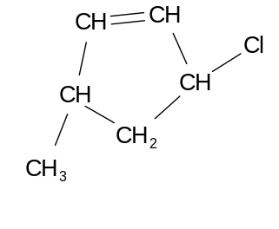
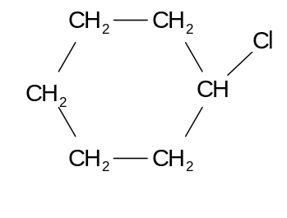
(A) (B)

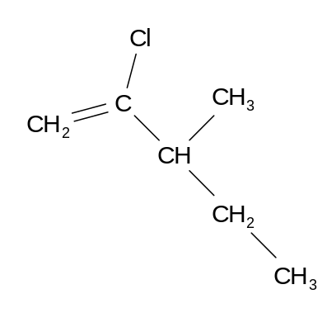
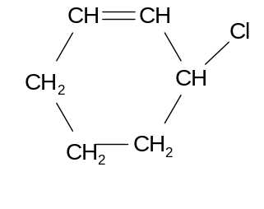
(C) (D)

- Consider the reaction:

CH₃CH=CHCH₃ + Br₂  Z

Z would be represented by

(A) CH₃CHBrCHBrCH₃
(B) CH₂BrCH₂CHBrCH₃
(C) CH₃CHBrCH₂CH₂Br
(D) CH₂BrCH₂CH₂CH₂Br

- Which pair of substances could be combined to make soap?

(A) Sodium hydroxide and an amide
(B) An amide and an amine
(C) Animal fat and calcium stearate
(D) Vegetable oil and sodium hydroxide

Short Answer (29 marks)

11. a) Draw condensed structural formulae to show the reaction of sodium with methylpropan-1-ol. . (2 marks)

b) Name the organic product resulting from the oxidation of methylpropan-1-ol with an excess of permanganate ions in the presence of sulfuric acid.
(1 mark)

__________________________________________________________________________

c) Why is it not possible to oxidise methylpropan-2-ol? (1 mark)

__________________________________________________________________________

__________________________________________________________________________

__________________________________________________________________________

d) Propan-1-ol will react with methanoic acid in the presence of hydrogen ions.
Give the name and structural formula of the organic product. (2 marks)

Name: _________________________________

Structural Formula:

e) Write a balanced equation for the complete combustion of methylpropane. (2 marks)

- Give the systematic names of the following organic compounds: (3 marks)

a) CH₃CHOHCH₃

__________________________________________________________________________

b) HCOOH

__________________________________________________________________________

c) CH₃CH₂COOCH₂CH₃

__________________________________________________________________________

- State the half-equations and overall redox equation that occurs when ethanal is warmed
with a water-solution containing potassium dichromate and sulfuric acid. (3 marks)

- a) Draw the full structural formulae, showing all bonds and all atoms, of three structural isomers with the molecular formula C₄H₈. (3 marks)

b) Only one of the structural isomers of C₄H₈ exhibits cis/trans isomerism.
Identify that isomer. Draw and name the two geometric isomers, in the correct box below.
(4 marks)
Cis isomer | Trans isomer

- You are asked to identify three colourless liquids. The liquids are known to be butan-1-ol,
propanoic acid and methyl ethanoate.

a) Give the full structure of each of these compounds. (3 marks)
butan-1-ol

propanoic acid

methyl ethanoate

b) Describe how you could identify each solution using only pieces of magnesium and an
acidified potassium dichromate solution. Your answer should include equations and
predicted observations for any reactions that take place. State symbols are not required
for these equations. (5 marks)

________________________________________________________________________________

________________________________________________________________________________

________________________________________________________________________________

________________________________________________________________________________

________________________________________________________________________________

________________________________________________________________________________

________________________________________________________________________________

________________________________________________________________________________

________________________________________________________________________________

________________________________________________________________________________

________________________________________________________________________________

________________________________________________________________________________

________________________________________________________________________________

________________________________________________________________________________

________________________________________________________________________________

________________________________________________________________________________

________________________________________________________________________________

END OF PAPER

